Quarterly Statistics by Banks, Employees and Branches

in Banking System

September 2018

Number of Banks

The number of deposit, development and investment banks was 52 at the end of September 2018 with 34 in deposit banks group and 13 in non-deposit banks group, while there were also 5 participation banks.

Number of Banks in the System
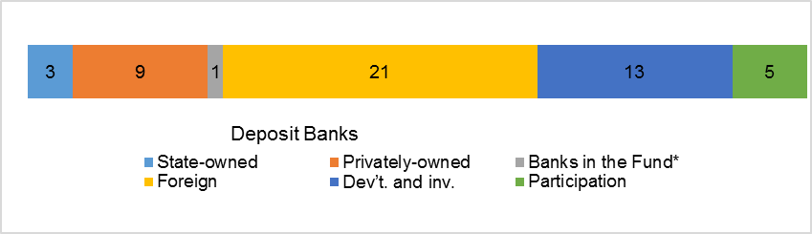* Banks under the Deposit Insurance Fund

Number of Employees

As of September 2018, the number of employees in deposit banks and development and investment banks was 193,343.

Number of Employees

 | September 2017 | June 2018 | September 2018
Deposit banks | 189,840 | 188,564 | 187,919
Dev’t. and inv. banks | 5,224 | 5,251 | 5,424
Total | 195,064 | 193,815 | 193,343

The number of employees decreased by 1,721 (1 percent), as compared to September 2017 and by 472 as compared to previous quarter.

Number of Employees

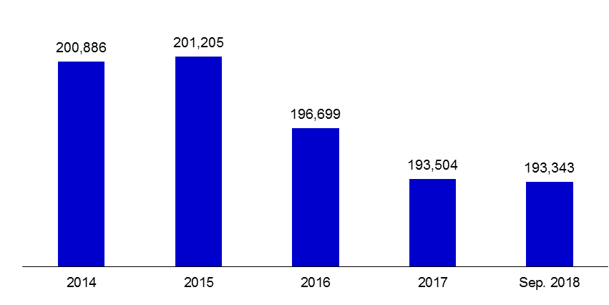

The average number of employees was 5,227 in deposit banks.

Bank Employees by Gender and Education Level

As of September 2018, 51 percent of the employees were female regarding the distribution of bank employees by gender.

Regarding the education level of bank employees, 79 percent of the employees had undergraduate degrees and 8 percent in postgraduate degrees, as of September 2018. This figure was 13 percent in high-school graduates.

Bank Employees by Gender and Education Level
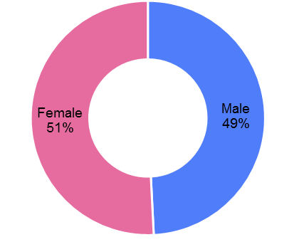
Number of Branches

As of September 2018, the total number of branches in deposit banks and development and investment banks was 10,505.

Number of Branches*

 | September 2017 | June 2018 | September 2018
Deposit banks | 10.609 | 10.483 | 10.452
Dev’t. and inv. banks | 49 | 53 | 53
Total | 10.658 | 10.536 | 10.505
* Branches in foreign countries and Turkish Republic of Northern Cyprus are included.

The number of branches decreased by 153, as compared to September 2017 and by 31 as compared to previous quarter.

Number of Branches

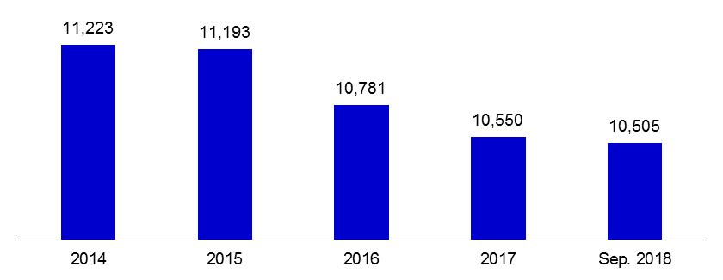
The number of branches per bank was 307 in deposit banks at the end of September 2018.

-The deposit banks and development and investment banks are included.

