Quarterly Statistics by Banks, Employees and Branches

in Banking System

December 2019

Number of Banks

The number of deposit, development and investment banks was 53 at the end of September 2019 with 34 in deposit banks group and 13 in non-deposit banks group, while there were also 6 participation banks.

Number of Banks in the System

* Banks under the Deposit Insurance Fund

Number of Employees

As of December 2019, the number of employees in deposit banks and development and investment banks was 188,837.

Number of Employees

 | December 2018 | September 2019 | December 2019
Deposit banks | 186,918 | 184,324 | 183,659
Dev’t. and inv. banks | 5,395 | 5,183 | 5,178
Total | 192,313 | 189,507 | 188,837

The number of employees decreased by 670 as compared to previous quarter and by 3,836 (2 percent), as compared to 2018.

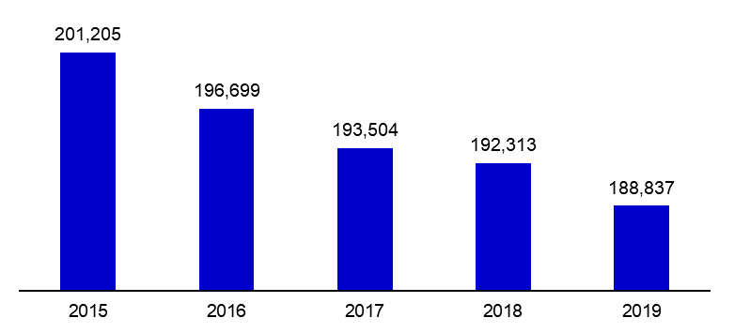
Number of Employees

Bank Employees by Gender and Education Level

As of December 2019, 51 percent of the employees were female regarding the distribution of bank employees by gender.

Regarding the education level of bank employees, 78 percent of the employees had undergraduate degrees and 8 percent in postgraduate degrees, as of December 2019. This figure was 13 percent in high-school graduates.

Bank Employees by Gender and Education Level
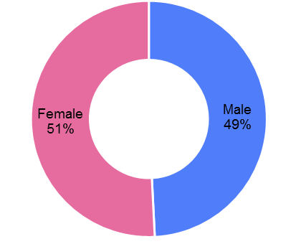
Number of Branches

As of December 2019, the total number of branches in deposit banks and development and investment banks was 10,199.

Number of Branches*

 | December 2018 | September 2019 | December 2019
Deposit banks | 10,400 | 10,231 | 10,137
Dev’t. and inv. banks | 54 | 58 | 62
Total | 10,454 | 10,289 | 10,199
* Branches in foreign countries and Turkish Republic of Northern Cyprus are included.

The number of branches decreased by 90, as compared to previous quarter and by 255, as compared to 2018.

The number of branches per bank was 298 in deposit banks at the end of 2019.

Number of Branches

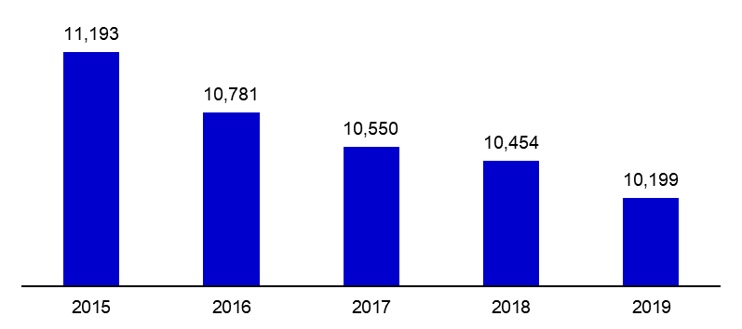

The rapid growth of non-branch channels and delegation of some services to outsourcing institutions affected the number of employees and branches.

Branches and Employees per 100,000 people

As of December 2019, employees per 100,000 people decreased 7 point to 227 as compared to end of the 2018.

Branches and Employees per 100,000 people

As of December 2019, employees per 100,000 people decreased 0.5 point to 12.3 as compared to end of the 2018.

-The deposit banks and development and investment banks are included.

