Quarterly Statistics by Banks, Employees and Branches

in Banking System

September 2020

Number of Banks

The number of deposit, development and investment banks was 54 at the end of September 2020 with 34 in deposit banks group and 13 in non-deposit banks group, while there were also 6 participation banks. “Golden Global Yatırım Bankası A.Ş.” was granted with an operation license with the BRSA resolution dated January 30, 2020 has started operations as of June 2020.

Number of Banks in the System

* Banks under the Deposit Insurance Fund

Number of Employees

As of September 2020, the number of employees in deposit banks and development and investment banks was 186.654.

Number of Employees

 | September 2019 | December 2019 | September 2020
Deposit banks | 184,324 | 183,659 | 181,487
Dev’t. and inv. banks | 5,183 | 5,178 | 5,167
Total | 189,507 | 188,837 | 186,654

The number of employees decreased by 836 as compared to previous quarter and by 2,853 (1.5 percent), as compared to September 2019.

Number of Employees
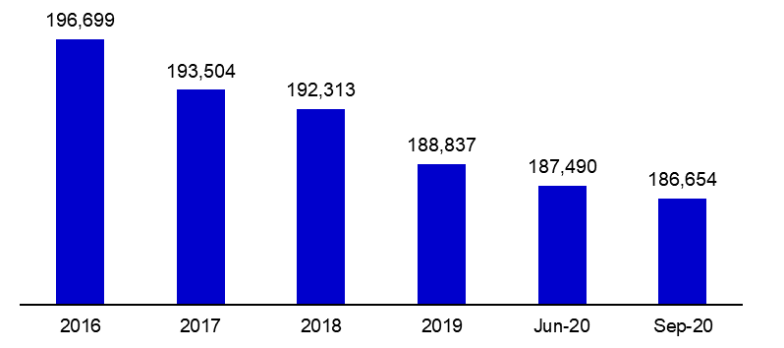

Bank Employees by Gender and Education Level

As of September 2020 50,4 percent of the employees were female regarding the distribution of bank employees by gender.

Regarding the education level of bank employees, 78 percent of the employees had undergraduate degrees and 8 percent in postgraduate degrees, as of September 2020. This figure was 13 percent in high-school graduates.

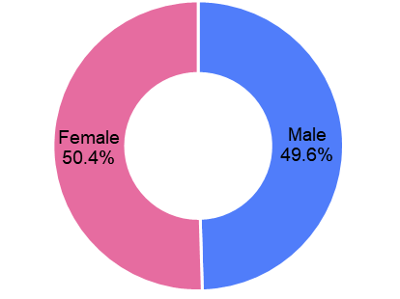
Bank Employees by Gender and Education Level

Number of Branches

As of September 2020, the total number of branches in deposit banks and development and investment banks was 10,079.

Number of Branches*

 | September 2019 | December 2019 | September 2020
Deposit banks | 10,231 | 10,137 | 10,015
Dev’t. and inv. banks | 58 | 62 | 64
Total | 10,289 | 10,199 | 10,079
* Branches in foreign countries and Turkish Republic of Northern Cyprus are included.

The number of branches decreased by 53, as compared to previous quarter and by 210, as compared to September 2019.

The number of branches per bank was 295 in deposit banks at the end of the September 2020.

Number of Branches
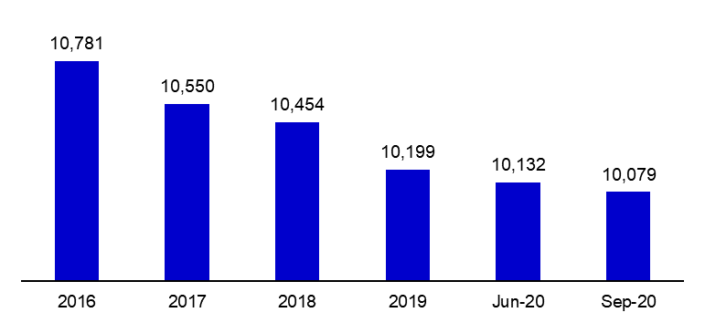

The rapid growth of non-branch channels and delegation of some services to outsourcing institutions affected the number of employees and branches.

Branches and Employees per 100,000 people

As of September 2020, employees per 100,000 people decreased 3 points to 224 as compared to end of the 2019.

Branches and Employees per 100,000 people*

*: 2019 population data were used in the calculations.

-The deposit banks and development and investment banks are included.

