Quarterly Statistics by Banks, Employees and Branches

in Banking System

December 2023

Number of Banks

The number of deposit, development and investment banks was 63 at the end of December 2023 with 34 in deposit banks group and 20 in development and investment banks group, while there were also 9 participation banks. With the decision of the Banking Regulation and Supervision Agency, "Hedef Yatırım Bankası A.Ş" was licenced to operate.

Number of Banks in the System

* Banks under the Deposit Insurance Fund

Number of Employees

As of December 2023, the number of employees in deposit banks and development and investment banks was 189,107.

Number of Employees

 | December 2022 | September 2023 | December 2023
Deposit banks | 182,963 | 183,125 | 182,790
Dev’t. and inv. banks | 5,700 | 6,127 | 6,317
Total | 188,663 | 189,252 | 189,107

The number of employees decreased by 145 as compared to previous quarter and it increased by 444 to December 2022.

The number of employees decreased by 173 in deposit banks and it increased by 617 in development and investment banks.

Number of Employees (Number of people)

Bank Employees by Gender and Education Level

As of December 2023, 50.7 percent of the employees were female and 49.3 percent were male, regarding the distribution of bank employees by gender.

Regarding the education level of bank employees, 79 percent of the employees had undergraduate degrees and 9 percent in postgraduate degrees, as of December 2023. This share of high-school graduates was 11 percent.

Bank Employees by Gender and Education Level

The age distribution of employees in the banking sector has been compiled and published by the Banks Association of Turkey since December 2022. Accordingly, 43 percent of employees are in the 36-45 age range, and 38 percent are in the 26-35 age range.

Bank Employees by Age (percent)

Number of Branches

As of December 2023, the total number of branches in deposit banks and development and investment banks was 9,497.

Number of Branches*

 | December 2022 | September 2023 | December 2023
Deposit banks | 9,589 | 9,543 | 9,422
Dev’t. and inv. banks | 71 | 73 | 75
Total | 9,660 | 9,616 | 9,497
* Branches in foreign countries and Turkish Republic of Northern Cyprus are included.

The number of branches decreased by 119, as compared to previous quarter and by 164, as compared to December 2022.

The number of branches per bank was 279 in deposit banks at the end of December 2023.

Number of Branches
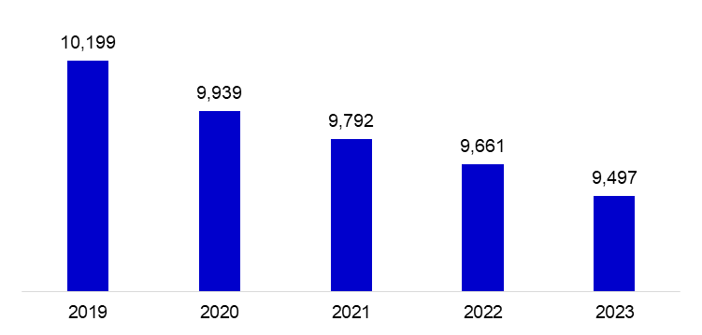

The rapid growth of non-branch channels and delegation of some services to outsourcing institutions affected the number of employees and branches.

Branches and Employees per 100,000 people

As of December 2023, employees per 100,000 people was 222 and branches per 100,000 people was 11.1.

Branches and Employees per 100,000 people*

* 2022 population data were used in the 2023 calculations.

-The deposit banks and development and investment banks are included for the figures of employees and branches.
The data on the number of employees was revised based on the updates received by the two banks.

