Quarterly Statistics by Banks, Employees and Branches

in Banking System

December 2024

Number of Banks

The number of deposit, development and investment banks was 67 at the end of December 2024 with 38 in deposit banks group and 20 in development and investment banks group, while there were also 9 participation banks. With the decision of the Banking Regulation and Supervision Agency, “Ziraat Dinamik Banka A.Ş.” (digital) bank and “Colendi Bank A.Ş.” (digital) deposit bank were licensed to operate.

Number of Banks in the System

* Banks under the Deposit Insurance Fund

Number of Employees

As of December 2024, the number of employees in deposit banks and development and investment banks was 187,918.

The number of employees decreased by 648 as compared to previous quarter and it decreased by 1,189 to December 2023.

Compared to December 2023, the number of employees decreased by 1,396 in deposit banks and it increased by 207 in development and investment banks.

Number of Employees (thousand people)
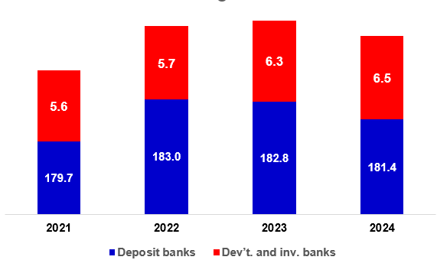

Bank Employees by Gender and Education Level

As of December 2024, 51.2 percent of the employees were female and 48.8 percent were male, regarding the distribution of bank employees by gender.

Regarding the education level of bank employees, 79 percent of the employees had undergraduate degrees and 10 percent in postgraduate degrees, as of December 2024. This share of high-school graduates was 11 percent.

Bank Employees by Gender and Education Level

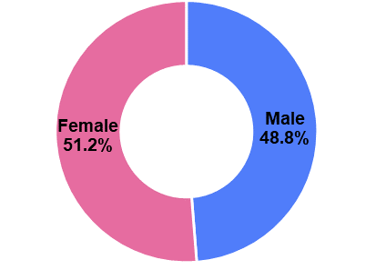

42 percent of employees are in the 36-45 age range, and 44 percent are in the 26-35 age range.

Bank Employees by Age (percent)

Number of Branches

As of December 2024, the total number of branches in deposit banks and development and investment banks was 9,329.

Number of Branches*
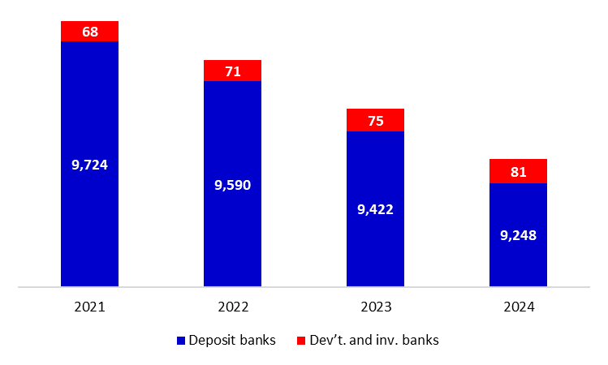

* Branches in foreign countries and Turkish Republic of Northern Cyprus are included.

The number of branches decreased by 130, as compared to previous quarter and by 168, as compared to December 2023.

Branches and Employees per 100,000 people

As of December 2024, employees per 100,000 people was 219 and branches per 100,000 people was 10.9.

Branches and Employees per 100,000 people*

* 2024 population data were used in calculations.

-The deposit banks and development and investment banks are included for the figures of employees and branches.

