Quarterly Statistics by Banks, Employees and Branches

in Banking System

June 2025

Number of Banks

The number of deposit, development and investment banks was 67 at the end of June 2025 with 38 in deposit banks group and 20 in development and investment banks group, while there were also 9 participation banks.

Number of Banks in the System

* Banks under the Deposit Insurance Fund

Number of Employees

As of June 2025, the number of employees in deposit banks and development and investment banks was 188,912.

The number of employees decreased by 59 as compared to previous quarter and decreased by 680 to June 2024.

Compared to June 2024, the number of employees decreased by 810 in deposit banks and it increased by 130 in development and investment banks.

Number of Employees (thousand people)
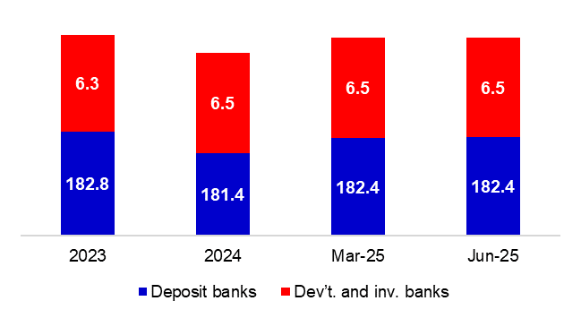

Bank Employees by Gender and Education Level

As of June 2025, 51.4 percent of the employees were female and 48.6 percent were male, regarding the distribution of bank employees by gender.

Regarding the education level of bank employees, 79 percent of the employees had undergraduate degrees and 10 percent in postgraduate degrees, as of June 2025. This share of high-school graduates was 10 percent.

Bank Employees by Gender and Education Level

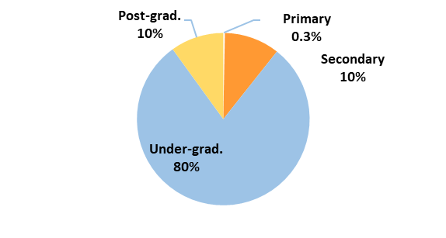
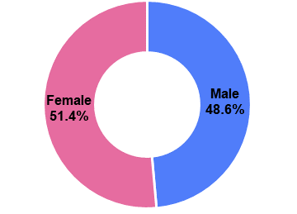

44 percent of employees are in the 36-45 age range, and 38 percent are in the 26-35 age range.

Bank Employees by Age (percent)

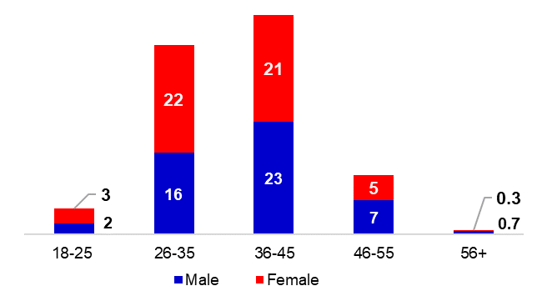

Number of Branches

As of June 2025, the total number of branches in deposit banks and development and investment banks was 9,324.

Number of Branches*
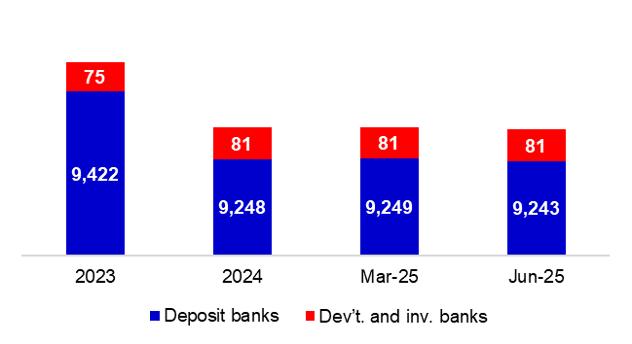

* Branches in foreign countries and Turkish Republic of Northern Cyprus are included.

The number of branches decreased by 6, as compared to previous quarter and decreased by 159, as compared to June 2024.

Branches and Employees per 100,000 people

As of June 2025, employees per 100,000 people were 221 and branches per 100,000 people were 10.9.

Branches and Employees per 100,000 people*
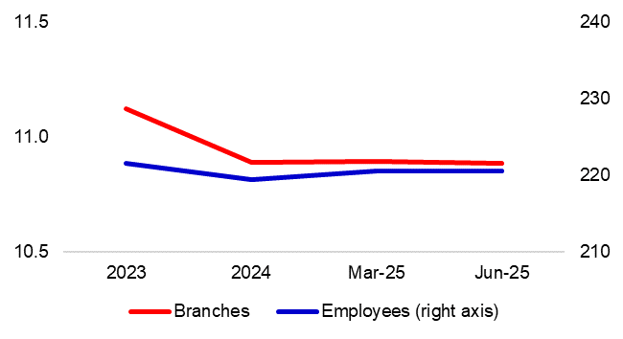
* 2024 population data were used in calculations.

-The deposit banks and development and investment banks are included for the figures of employees and branches.

