Quarterly Statistics by Banks, Employees and Branches

in Banking System

September 2025

Number of Banks

The number of deposit, development and investment banks was 68 at the end of September 2025 with 38 in deposit banks group and 21 in development and investment banks group, while there were also 9 participation banks.

Number of Banks in the System

* Banks under the Deposit Insurance Fund

Number of Employees

As of September 2025, the number of employees in deposit banks and development and investment banks was 187,981.

The number of employees increased by 931 as compared to previous quarter and decreased by 585 to September 2024.

Compared to September 2024, the number of employees decreased by 695 in deposit banks and it increased by 110 in development and investment banks.

Number of Employees (thousand people)
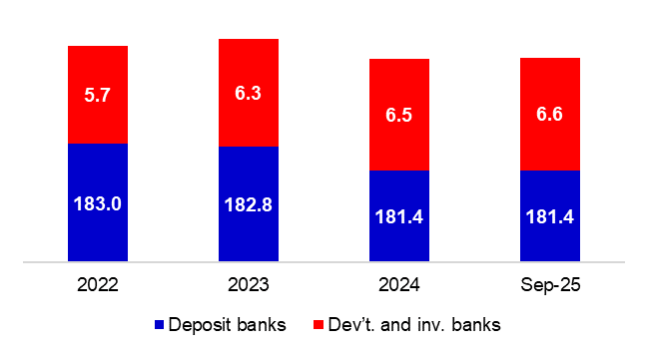

Bank Employees by Gender and Education Level

As of September 2025, 51.3 percent of the employees were female and 48.7 percent were male, regarding the distribution of bank employees by gender.

Regarding the education level of bank employees, 81 percent of the employees had undergraduate degrees and 10 percent in postgraduate degrees, as of September 2025. This share of high-school graduates was 10 percent.

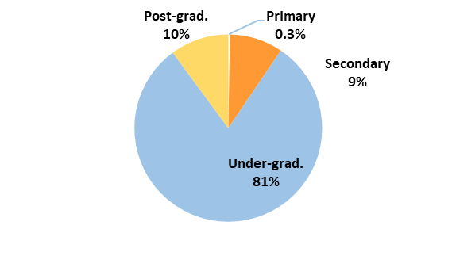
Bank Employees by Gender and Education Level
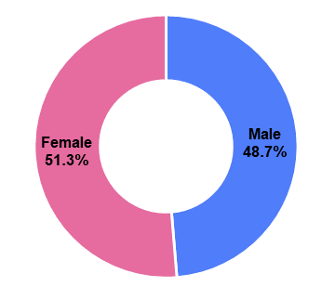

45 percent of employees are in the 36-45 age range, and 37 percent are in the 26-35 age range.

Bank Employees by Age (percent)

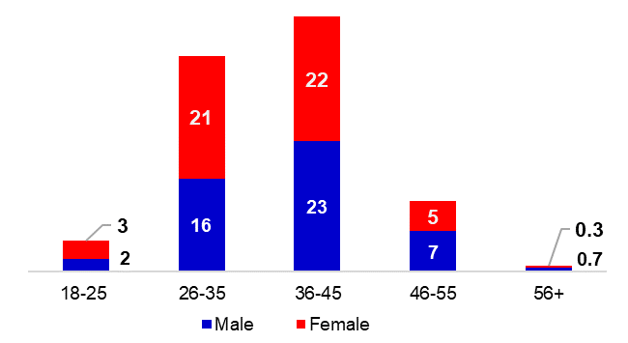

Number of Branches

As of September 2025, the total number of branches in deposit banks and development and investment banks was 9,259.

Number of Branches*
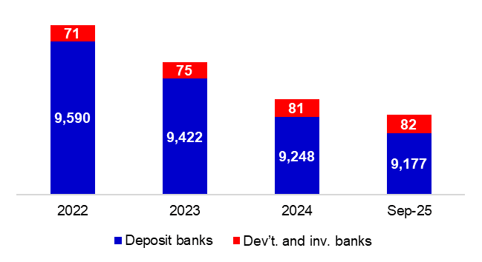

* Branches in foreign countries and Turkish Republic of Northern Cyprus are included.

The number of branches decreased by 65, as compared to previous quarter and decreased by 200, as compared to September 2024.

Branches and Employees per 100,000 people

As of September 2025, employees per 100,000 people were 219 and branches per 100,000 people were 10.8.

Branches and Employees per 100,000 people*
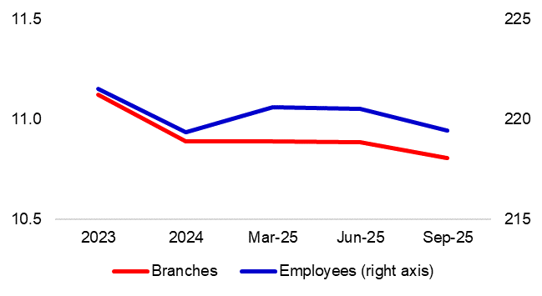
* 2024 population data were used in calculations.

-The deposit banks and development and investment banks are included for the figures of employees and branches.

