Banking System in Turkey
“September 2012”

Developments in the Banking Sector

1. General Outlook

Global growth is slow; risk perception is still high.

The ongoing debt crises in European Union and uncertainties regarding the future of the Euro continue to keep risk appetite at relatively low levels in the international markets. Besides, current concerns over the Fiscal Cliff, political turmoil in the Middle East and price volatility in commodities and energy market make the global economy riskier.

During the year of 2012, international financial institutions revised their forecasts on the global economic growth downwards. Along with slower growth rate not enough to reduce the unemployment rate in advanced economies and decelerating pace of growth in the emerging countries threatens global economic outlook.

In this circumstance, low cost liquidity injection to the market continues by advanced economies. While US Federal Reserve, European Central Bank and Bank of Japan boost low cost liquidity to the market, emerging countries revised their policy rates downwards.

Monetary and banking sector policies have continued to be prudent in the second half of the year 2012. The priority was given to the policies that would decelerate the economic growth and constrain current account deficit since the second half of last year. Thanks to the contribution of net exports to growth has increased markedly, current account has continued to improve.

Monetary and banking sector policies have continued to be prudent.

Due to uncertainties in the global economy, volatility in financial markets and upside risks regarding inflation outlook, the CBRT implemented monetary tightening during the first half of 2012. In the second half of the year either disinflationary impact of domestic demand or improvement in the current account balance, the CBRT increased the liquidity injected to the market and decreased its average funding rate gradually.

Besides, regulations on the allowance of the reserve requirements for TL liabilities to be held as FX and gold has enabled the Turkish banking system to meet its liquidity needs at a relatively lower cost. Furthermore, in order to increase the resilience of the economy against external financial shocks, the CBRT introduced the Reserve Option Mechanism (ROM) in the third quarter of the year. Banks used the facilities provided by the CBRT. The utilization ratio of the facilities is about 90 percent. Thanks to ROM, CBRT’s FX and gold reserves increased at a relatively high level.

Against the risk of highly volatile short-term capital flows that lead to deterioration in the financial stability following the raise of Turkey to investment grade in November, the CBRT has continued to be prudent.

Appetite for loans and deposits diminished.

The ongoing uncertainties in global economy, decelerating economic activity and prudential measures taken by the central bank have impacted the banking sector significantly. Compared to the same period of last year, appetite on both loans and deposit decreased.

By September 2012, growth rate of total assets, loans and deposits decelerated to 8.6, 13.6 and 7.1 percent respectively.

In annual basis, profitability ratios remain constant compared to last year. While return on equity is around 13.3 percent, return on assets at the rate of 1.7 percent by September 2012.

2. Developments in Balance Sheet Items

Total assets increased by 8.6 percent by September 2012 compared to the same period of 2011. As of September 2012, total assets were TL 1,244 billion (USD 697 billion).

Total assets increased by 6.3 percent in deposit banks and 33 percent in development and investment banks, as compared to the September 2011.

Total Assets (USD billion) and Total Assets/Gdp (percent)
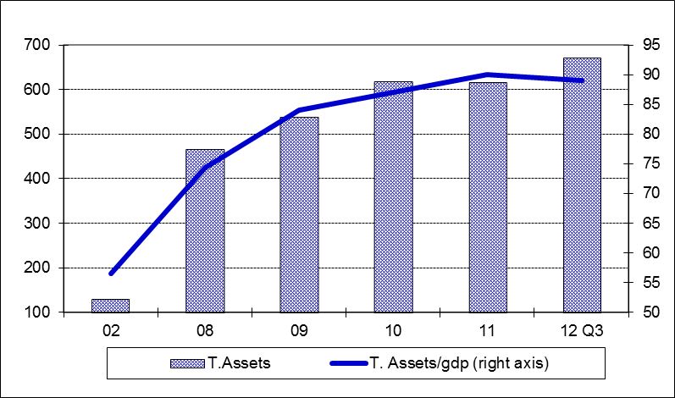
During the third quarter of 2012, while the share of state owned banks both in total assets and loans of the sector decreased by 1 point, the share of the private and foreign banks remained constant.

Given the constant currency basket (0.5 euro + 0.5 USD) by the end of 2010, total loans’ growth rate was realized at 12.6 percent in the first nine months of 2012 and 16.4 percent year over year.

The ratio of loans to total assets realized at 59 percent by increasing 3 percentage points as compared to September 2011. Loans to deposits ratio was 98 percent by increasing 4 percentage points in the same period. The same ratio was 83 percent in state-owned banks, 105 percent in private banks and 111 percent in foreign banks as of September 2012.

The ratio of non-performing loans (NPLs, gross) to loan stock increased to 3 percent due to deceleration of economic growth by the end of September 2012. Notably, provisions set aside for the non-performing loans diminished in the same period.

Total deposits financed 60 percent of total assets. The non-deposit funds to total assets were 24 percent by September 2012.

3. Profitability

Shareholders’ equity was TL 161 billion as of September 2012 with an increase of 19 percent compared to September 2011 mainly due to rise in profit reserves.

Compared to September 2011, the capital adequacy ratio remained the same at the rate of 16.5 percent by the end of September 2012. The ratio of free shareholders’ equity to total assets became 10 percent in this period.

In the first nine months of the year, while the interest income of the sector increased by 30 percent, interest expenses grew at 27 percent. Thus, net interest income increased by 34 percent compared to the same period of 2011. The total profit volume of the sector increased by 17 percent by September 2012 compared to the same period of the last year and reached at TL 16.4 billion.

In annual basis, profitability ratios remain constant compared to last year. While return on equity is around 13.3 percent, return on assets at the rate of 1.7 percent by September 2012.

Net foreign exchange position of the banking sector showed a deficit of USD 644 million. Compared to September 2011, the ratio of TL equivalent of FX assets to total assets increased by 1 percent to 30 percent, while the ratio of TL equivalent of FX liabilities to total liabilities increased by 1 percent to 36 percent.

Considering maturity, 49 percent of total assets and 83 percent of total liabilities had a maturity of less than 1 year. There was not a considerable change in the average maturity structure of total assets and liabilities compared to June 2012.

A 1.2 percent (TL 8.7 billion) of loans and a 3.3 percent (TL 24.2 billion) of total deposits belong to the risk group of banks. Banks’ net risks arising from their risk groups amount was negative. (TL -16 billion).

4. Selected Issues

The number of branches and employees increased.

As of September 2012, 44 banks are operating in Turkey. The number of branches and employees increased by 132 and 978 to 10,111 and 184,332 in the same period, respectively. The share of first five banks in total assets increased by 2 percent to 62 percent while their shares in total loans and deposits remain constant at the rate of 57 and 61 percent respectively compared to September 2011. Also the share of first ten banks in total assets and deposits remain constant at the rate of 88 and 91 percent respectively while shares in loans decreased by 1 percentage point to 86 percent.

Deposit banks and development and investment banks are included.

