Banking System in Turkey

“June 2015”

Despite the restricted recovery in growth performance of developed countries, global growth rate is still low due the weak economic performance of developing countries. This has caused a volatility in capital flows to developing countries.

Turkish economy continued to grow in the first half of the year. The continued increase of bank loans had a positive contribution to this development. The declining trend in individual loans stopped, and corporate loans continued to increase. Profit volume, which declined nominally in 2014 due to the macroprudential regulations, had a limited increase of 11% in the first half of 2015 compared previous year. Hence the return on equity declined, and capital adequacy continued to decline.

1. General Outlook

Global growth remained low, and volatility in financial markets increased

The uncertainties on the volume and timing of the policy rate increase of Fed, caused a period with more uncertainties and higher risks. There were severe fluctuations in financial markets in Euro Area also with the developments in Greece.

The slowdown in developed countries continued in the first half of 2015. While China’s economic activity’s weak outlook continued, there was contraction in both Brazil and Russia’s economies. In developing countries, policy interest rates were in downward trend in general. The decline in oil prices slowed down and there was even a restricted increase.

The slowdown in global economy and geopolitical risks affect the Turkish Economy’s performance negatively.

The annual growth rate in Turkish economy was 2.3 percent in the first quarter of 2015. The resurgence in domestic consumption had an effect on this growth. But the slowdown in private investments continued. Despite the revival in industrial production which is one of the leading indicators, the confidence indices had a negative pressure on economic growth. While the decrease in oil prices had a positive impact on imports, the foreign trade deficit contraction was restricted by the slowdown in exports due to geopolitical developments and global slowdown. The ratio of current trade deficit to gdp was estimated 5.8 percent.

Central Bank continued cautious monetary policy.

Due to the higher than expected inflation level, the Central Bank continued its cautious monetary policy stance in the second quarter of 2015. The policy rate was not changed during this period.

Growth was above the expectations.

Individual loans, the growth rate of which decreased in 2014 due to macroprudential measures, started to grow in the first half of 2015 though at a low acceleration and limitedly. Corporate loans on the other hand had an upward trend. The ratio of non-performing loans to total loans was 2.7 percent as of June 2015.

The ratio of loans to deposits was 116 percent. Also with the effect of the depreciation TL against prominent FX currencies, the share of FX nominated deposits in total deposits increased. The ratio of total deposits to total assets remained same compared to the same period of 2014.

Increased loan demand supported growth and loan growth continued

The profitability of the banking sector deteriorated in the first half of the year despite the relative increase in loan demand. The average return on equity which was 12.1 percent by December 2014, decreased to 11.9 percent by June 2015. The difference between the return on equity and the interest on the risk free investment instrument, domestic borrowing securities continued to narrow. The volume of profits increased by 11 percent in TL terms and decreased by 12 percent in USD terms in the first half of the year compared to the previous year. The regulations that increase the costs and restrict the income of banks, and the increase in the special provisions for non-performing loans were the main reasons behind the decrease in return on equity.

The capital adequacy ratio of the banking sector was realised 15.4 percent, 1 percentage point lower compared to the same period of last year.

2. Developments in Balance Sheet Items

Total assets increased by 21.8 percent in TL terms by June 2015 compared to the same period of 2014 and reached TL 2,107 billion (USD 785 billion). The ratio of total assets to gdp is estimated 116 percent as of June 2015.

Compared to the June 2014, total assets increased by 22 percent and 27 percent in deposit and development and investment banks, respectively.

By June 2015, compared to the same period of last year, the share of state owned banks and foreign owned banks in total assets increased each by 1 percentage point to 31 percent and 16 percent, respectively. The share of the private banks was 50 percent. While the shares of state-owned banks and private banks in loans increased 2 points and 1 point, share of foreign banks decreased. On the contrary, state owned banks’ share in total deposit remained unchanged by 33 percent. The share of private banks decreased by 1 point to 51 percent, whereas the share of foreign owned banks increased by 1 point to 16 percent.

The annual growth rate of retail loans realized as 10 percent in the first quarter and continued to rise in the second quarter of the year. The declining trend in credit cards reversed to increase and growth rate of housing loans accelerated. Corporate loans increased 31 percent yearly.

Total Assets (USD billion) and Total Assets/Gdp (percent)

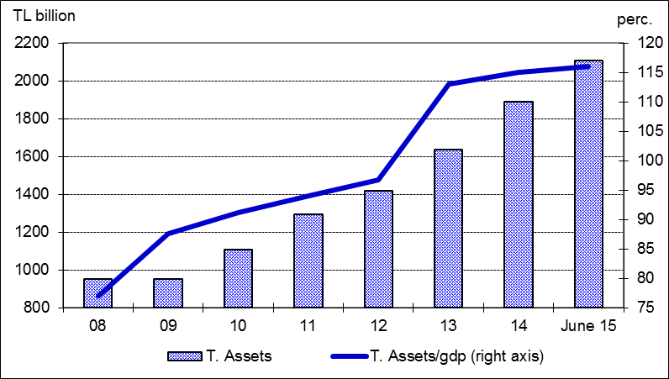

The ratio of loans to total assets remained unchanged at 63 percent. Loans to deposits ratio was 116 percent by increasing 5 points compared to the same period of last year. The same ratio was 105 percent in state-owned banks, 112 percent in private banks and 114 percent in foreign banks as of June 2015.

Non performing loans increased annually by 20 percent in fixed FX rates. The ratio of non-performing loans (NPLs, gross) to loan stock remained at 2.7 percent. Notably, provisions set aside for the NPLs were at the level of 76 percent. On the other hand, NPLs that are sold to asset management companies are calculated to be 1 percent of total loans.

The high rate of growth in the non-deposit funds of the banking sector continued in the first half of the year. Non-deposit funds increased by 30 percent annually, securities issued by banks increased by 40 percent and reached TL 101 billion. TL’s depreciation was also effective in the increase of the non-deposit funds of whose TL equivalent of the FX items was 71 percent.

The share of TL savings deposits in total deposits fell by 2 point to 33 percent compared to the same month of the previous year. The share of foreign currency deposits accounts increased by 3 percentage points to 40 percent due to the depreciation of TRY.

Shareholders’ equity was TL 233 billion (USD 87 billion) as of June 2015 with an increase of 14 percent compared to June 2014. The growth rate of shareholders’ equity was lower than total asset’s growth rate. Also, the share of equity in total liabilities was 11 percent.

In the first half of the year, interest income and interest expenses of the sector increased by 16 and 11 percent. Thus, net interest income increased by 21 percent compared to the same period of 2014 in TL terms, whereas it decreased by 4 percent in USD terms. Non interest income and non interest expenses increased by 10 percent and 20 percent, respectively. By June 2015 the total profit volume of the sector rose by 11 percent compared to the same period of the last year and realized as TL 13.2 billion.

Shareholders’ Equity (TL billion) and Capital Adequacy Ratio (perc.)

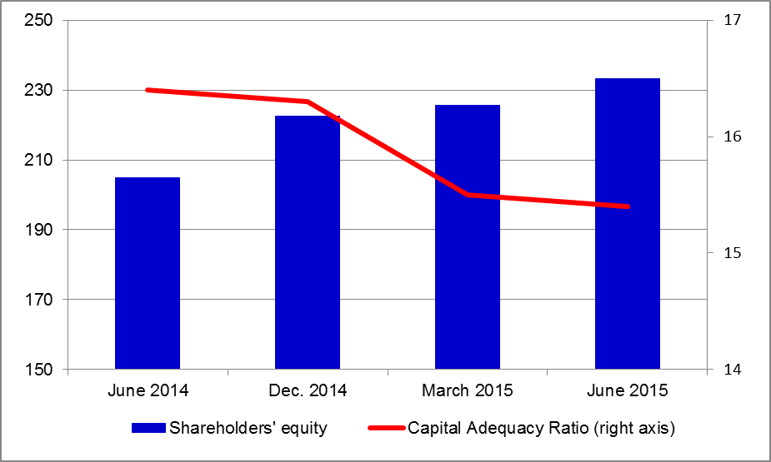

By June 2015, the ratio of TL equivalent of FX assets to total assets and the ratio of TL equivalent of FX liabilities to total liabilities became 37 and 46 percent respectively. Net FX short position of the banking sector realized as USD 1.2 billion. The ratio of net FX position to shareholders equity is 1 percent.

Considering maturity, 49 percent of total assets and 77 percent of total liabilities had a maturity of less than 1 year. The assets and liabilities with a more than 5 year maturity have a 16 percent and 4 percent shares in total assets and in total liabilities, respectively.

3. Concentration

According to asset sizes, shares of the first largest ten banks in total deposits remained unchanged at 90 percent. Their shares in total assets and loans declined by 1 percentage point to 85 and 84 percent, respectively.

Concentration in The Banking Sector

 | 2012 | 2013 | 2014 | June 2015
Largest five*
Assets | 60 | 58 | 58 | 58
Deposits | 61 | 59 | 59 | 60
Loans | 56 | 56 | 56 | 56
Largest ten*
Assets | 87 | 86 | 86 | 85
Deposits | 91 | 90 | 90 | 90
Loans | 86 | 85 | 85 | 84
* In terms of total assets
Source: BAT

As of June 2015, the first five banks were composed of 1 state-owned and 4 private banks, and the first ten banks were composed of 3 state-owned, 5 private and 2 foreign banks.

The Number of Banks by Asset Size ( June 2015)

USD billion | 0-2 | 2-10 | 10-40 | 40-80 | 80+
Deposit banks | 15 | 6 | 6 | 3 | 4
State |  |  |  | 2 | 1
Private | 2 | - | 1 | 1 | 3
Foreign | 12 | 3 | 5 | - | -
Fund | 1 | 3 | -
Dev. and Inv. banks | 8 | 4 | 1 | - | -
Total | 23 | 10 | 7 | 3 | 4

There were 4 banks with an asset size of more than USD 80 billion, and 3 banks with an asset size of between USD 40 billion and USD 80 billion. However, asset size of 40 banks was below USD 10 billion.

4. Selected Issues

As of June 2015, 47 banks were operating in Turkey. The number of branches and employees increased by 139 and 2,997 to 11,276 and 201,891 in the same period, respectively.

Also there are 5 participation banks in Turkey. The detailed information about participation banks is available http://www.tkbb.org.tr/homepage on The Participation Banks Association of Turkey.

Deposit banks and development and investment banks are included.

