Quarterly Statistics by Banks, Employees and Branches

in Banking System[1]

December 2017

Number of Banks

The number of deposit, development and investment was 52 at the end of December 2017 with 34 in deposit banks group and 13 in non-deposit banks group, while there were also 5 participation banks. Bank of China Turkey A.Ş. has taken permission to make banking operations in the "foreign banks founded in Turkey" group, on the 2nd of May, 2016 and started its operations on the 1st of December, 2017.

**Number of Banks in the System**

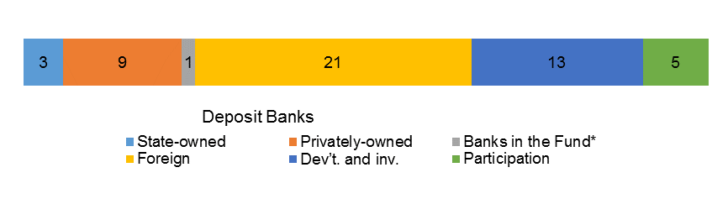

*\* Banks under the Deposit Insurance Fund*

Number of Employees

As of December 2017, the number of employees in deposit banks and development and investment banks was 193,504.

Number of Employees

|  |  |  |  |
| --- | --- | --- | --- |
|  | **December 2016** | **September 2017** | **December 2017** |
|  |  |  |  |
| Deposit banks | 191,363 | 189,840 | 188,266 |
| Dev’t. and inv. banks | 5,336 | 5,224 | 5,238 |
| **Total** | **196,699** | **195,064** | **193,504** |

The number of employees decreased by 3,195 (1.6 percent), as compared to December 2016 and by 1,560 as compared to September 2017.

**Number of Employees**

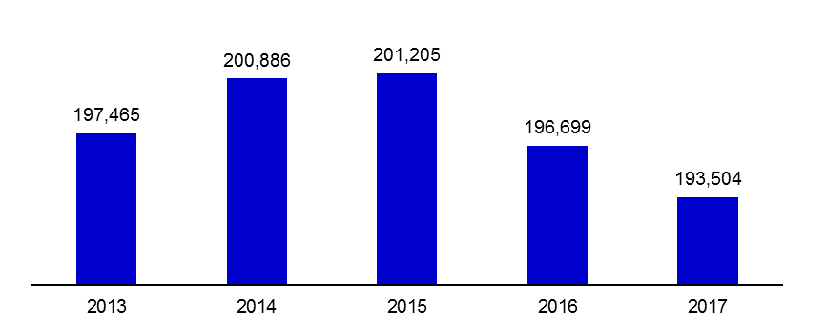

The average number of employees was 5,537 in deposit banks.

Bank Employees by Gender and Education Level

As of December 2017, 51 percent of the employees were female regarding the distribution of bank employees by gender.

Regarding the education level of bank employees, 79 percent of the employees had undergraduate degrees and 7 percent in postgraduate degrees, as of December 2017. This figure was 14 percent in high-school graduates.

Bank Employees by Gender and Education Level

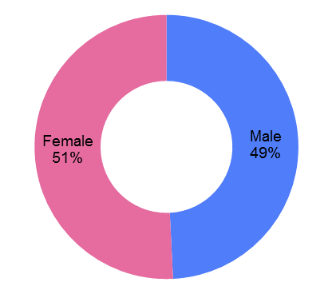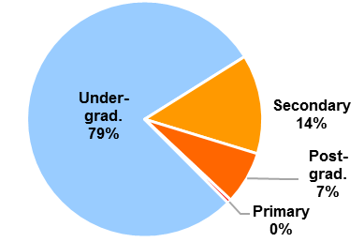

Number of Branches

As of December 2017, the total number of branches in deposit banks and development and investment banks was 10,550.

**Number of Branches\***

|  |  |  |  |  |
| --- | --- | --- | --- | --- |
|  | **December 2016** | **September 2017** | **December 2017** |  |
|  |  |  |  |  |
| Deposit banks | 10,740 | 10,609 | 10,500 |  |
| Dev’t. and inv. banks | 41 | 49 | 50 |  |
| **Total** | **10,781** | **10,658** | **10,550** |  |

*\* Branches in foreign countries and Turkish Republic of Northern Cyprus are included.*

This number decreased by 231, as compared to December 2016 and by 108, as compared to September 2017.

Number of Branches

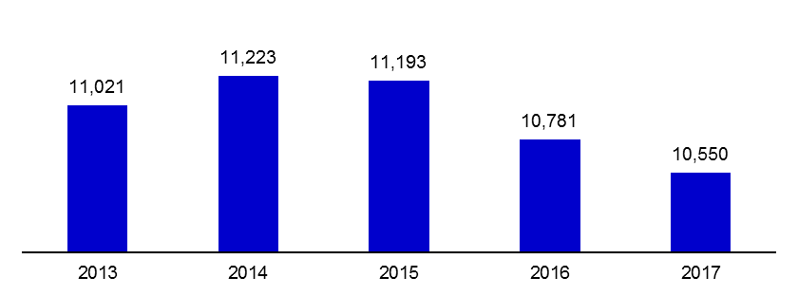

The number of branches per bank was 309 in deposit banks at the end of December 2017.

**Number of Branches and Employees per 100,000 People**

The number of branches per 100,000 people was 13 and the number of employees was 239 as of December 2017.

**Number of Branches and Employees per 100,000 People**

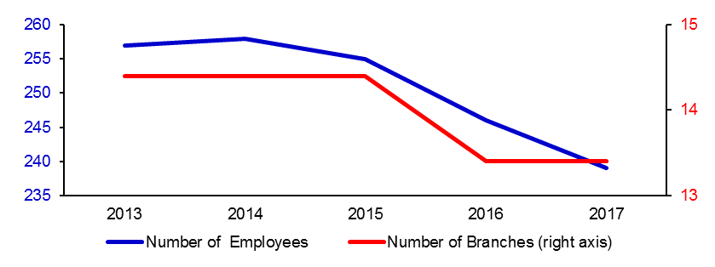

**Employees and Branches per 100,000 People**

|  |  |  |
| --- | --- | --- |
|  | Employees (people) | Branches |
| Euro Area | 575 | 44 |
| Emerging Countries | 379 | 12 |
| Turkey | 239 | 12 |

Source: BIS

Emerging Countries: Brazil, Hong Kong, India, Korea, Mexico, Singapore

According to BIS data, in Euro Area, the number of employee and branches per 100,000 people is 549 and 35, respectively.

1. -The deposit banks and development and investment banks are included.