Quarterly Statistics by Banks, Employees and Branches

in Banking System

March 2026

Number of Banks

The number of deposit, development and investment banks was 68 at the end of March 2026 with 37 in deposit banks group and 21 in development and investment banks group, while there were also 10 participation banks.

Number of Banks in the System

* Banks under the Deposit Insurance Fund

Number of Employees

As of March 2026, the number of employees in deposit banks and development and investment banks was 189,024.

The number of employees decreased by 612 as compared to previous quarter and increased by 53 to March 2025.

Compared to March 2025, the number of employees decreased by 194 in deposit banks and it increased by 247 in development and investment banks.

Number of Employees (thousand people)

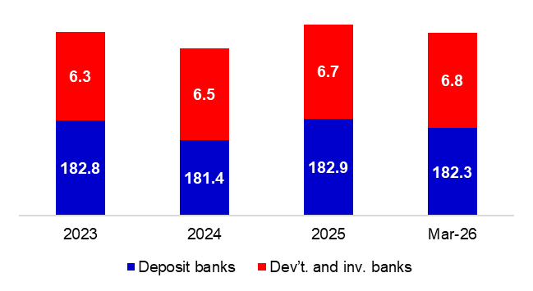
Bank Employees by Gender and Education Level

As of March 2026, 51.5 percent of the employees were female and 48.5 percent were male, regarding the distribution of bank employees by gender.

Regarding the education level of bank employees, 80 percent of the employees had undergraduate degrees and 11 percent in postgraduate degrees, as of March 2026. This share of high-school graduates was 9 percent.

Bank Employees by Gender and Education Level

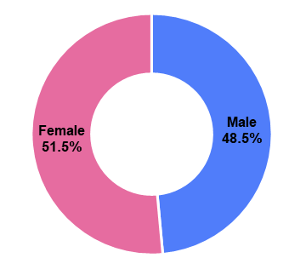
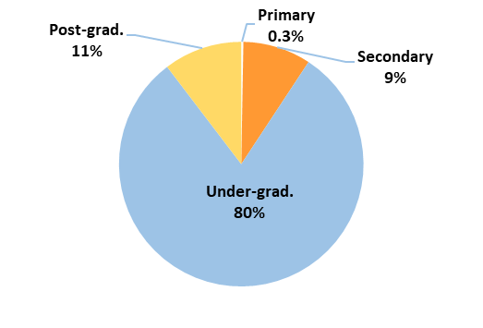

44 percent of employees are in the 36-45 age range, and 37 percent are in the 26-35 age range.

Bank Employees by Age (percent)

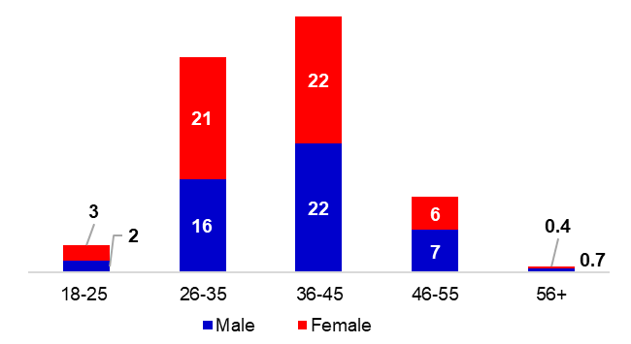

Number of Branches

As of March 2026, the total number of branches in deposit banks and development and investment banks was 9,149.

Number of Branches*
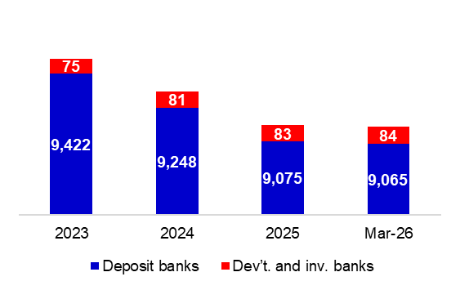

* Branches in foreign countries and Turkish Republic of Northern Cyprus are included.

The number of branches decreased by 9, as compared to previous quarter and decreased by 181, as compared to March 2025.

Branches and Employees per 100,000 people

As of March 2026, employees per 100,000 people were 220 and branches per 100,000 people were 10.6.

Branches and Employees per 100,000 people*
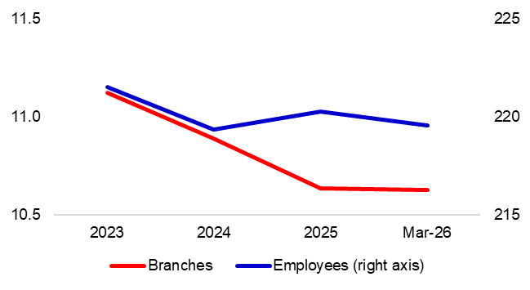
* 2025 population data were used in calculations.

-The deposit banks and development and investment banks are included for the figures of employees and branches.

